Somerset Virtual School and Learning Support Team

SEMH Snapshot Summer Term 2022
Please share the strategies, ideas and content of this SEMH Snapshot with your staff.

Dear Designated Teacher

The Virtual School and Learning Support Team hope that the Summer Term has started well for you. As always, we would like to thank you for all that you do to support care experienced children and young people in your school. This SEMH SNAPSHOT focusses on 2 key anxiety provoking areas for all children: Transitions and Exams / Assessments and is especially relevant to care-experienced young people.

In this SEMH Snapshot we have:

- Supporting transitions from one year group/ class/ school to the next.

- Helping to reduce and support anxiety around examinations and assessments

Supporting transitions from one year group/ class/ school to the next.

Children and young people who are care experienced face the challenge of repeated “new starts”. Not only the initial move into care but subsequent moves of foster home often resulting in changes of school. Planned and natural changes in schools and classes can then evoke feelings of loss and abandonment and a loss of control, which can be more pronounced than for children who have not experienced trauma and loss. As professionals, supporting young people in care or previously in care, it is important we have a good understanding of how these changes impact them and what we can do to help.

Catherine Steadman, one of our Learning Mentors, recently listened to a Year 11 care experienced young person as she shared her experiences of changing care placement and school and the impact this had on her. The following are her own words:
“The hardest time for me was when I had several moves of care placement in a short period of time, this affected me the most. It affected me physically and mentally. This was the time I started self-harming and felt suicidal. There was no consistency, no safe place, it’s when the spark came out of my eyes.

Because of this, things were difficult in school, I didn’t feel supported, and my behaviour got worse. In the end I had to leave. I was off school for a long time. I found a new school, but I was worried about not being liked. It was further away, and I was starting during lockdown so didn’t know what it was going to be like.

What helped with my school move was having a good support network and consistent care placement. It was local to where I was living, and I knew some people already.

Since starting there I have done really well. What helped me was going to the right school that understood me and wanted me, having good support staff in school and a secure foster placement.

My advice to other kids facing the same situation is, a new start can be good. It’s scary but it’s worth it, don’t judge it before it happens.

My advice to adults would be, listen to us, listen to what we think is best for us. Be there regardless of the ups and downs. Be there on the first day when we cry because someone took the mick out of our bag or clothes and change it if you can”

Catherine stated “What a privilege it was to sit and hear this young woman reflect on the ups and downs of moving and new starts. The key message I took away from it was that young people want support from people who will turn up, be there, listen and show them they are valued and wanted.”

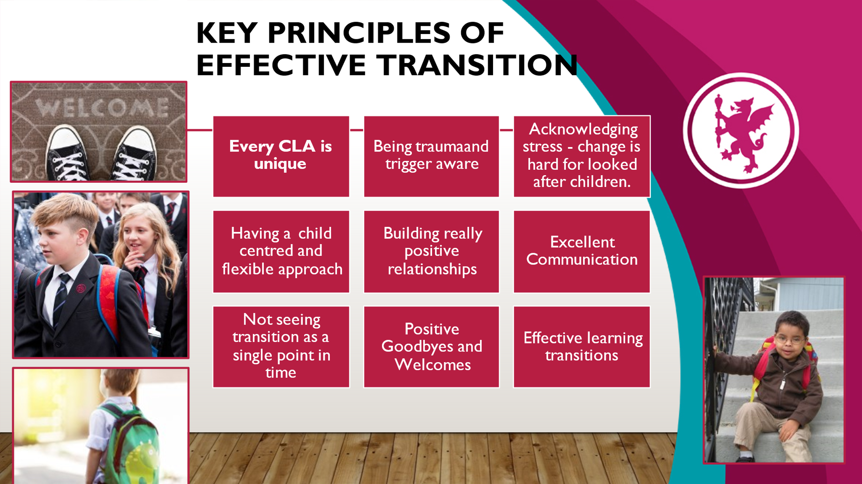

Top Transition Activities and Strategies to support CLA and PLAC

Essential - Hold a child-centred Transition Planning Meeting – create a transition plan with orientation visits, extra moving up days. Give photos or names of new staff new areas

A great idea to try - Transition Detectives – young person and a chosen group become “experts on the new class”/ school and create a presentation to the rest of the class. If there are several children moving, each could be a different transition expert e.g. A PE Transition Detective might find out all about Sports and a Lunchtime Transition Detective might find out all about the canteen, clubs, safe places at lunchtimes etc.

Other good practice ideas –

Awareness of the impact of neglect and trauma and the feelings of rejection or loss which can trigger anxiety – school staff being attachment and trauma aware.

Good “Goodbyes. Memory book / box from previous class / school

Planning for academic and pastoral support - not “waiting to see how a YP gets on”. Bridging projects – academic work or sharing prior work – e.g. a sample of best primary written work stuck into secondary school English book.

Encourage birth family involvement where appropriate – e.g., a “good luck in your new school” card.

Spot the difference game between schools or classes. Treasure Hunt, Sticker collection – people, places children (drawings)

Buddies / New pupil champions or older pupils come in to talk to pupils about moving but having extra sessions like this for CLA

Displaying a piece of work by the YP in the new classroom on a transition visit

Summer (or other holiday contact with school / staff)

Keeping in touch (school staff) A postcard or visit from a previous member of staff.

Current teacher encouraging talking about the new school / class and allowing a YP to show and tell about their new school.

Helping to reduce and support anxiety around examinations and assessments

Care experienced young people may experience heightened stress and anxiety around exams. Of course, most children find all types of assessment stressful, but care-experienced children may find the feelings of loss of control, fear of failure, fear of the future and fear of rejection and low self-worth even more extremely due to the exams triggering bodily responses linked to their prior trauma and loss.

Attached to this snapshot are 2 resources from somerset Educational Psychology Service – to support young people with exam stress – the first is a “Test Anxiety Inventory”. Use this with YP who struggle in exams and assessments to help find the way their test anxiety is manifesting in their bodies and then use the other resource “Exam Pack – Reduce Stress” for strategies that can help with those stress symptoms.

This is a useful series for some YP suffering with exam stress – click the image for the link!

Top tips For Schools
- Provide reassurance - Remind pupils of past successes and give them the opportunity to say how they are feeling.
- Support exam preparation - Hold revision classes, create study schedules for pupils and encourage them to revise in pairs or groups. Make these as attractive to care experienced children as you can.
- Share relaxation techniques - Controlled breathing and mindfulness techniques can help calm anxieties around exams.
This website will give you further information - Academic and exam stress : Mentally Healthy Schools

Please share any ideas you have for inclusion in future SEMH Snapshots, or any feedback to email address VirtualSchool@somerset.gov.uk

