
Somerset Virtual School and Learning Support Team
June 2021
Dear Designated Teacher

We hope you had a restful half term break and had chance to recharge. It certainly has been another very difficult year for staff and young people and as we head into our final half-term, we hope that some of the ideas in this edition of SEMH SNAPSHOTS will be of benefit to you, your colleagues and your pupils.

Feel free to email us with your feedback on these “Snapshots” and also if you have any suggestions for us to include. As before, these ideas will be applicable to all young people with SEMH needs but will be especially helpful; to consider for Looked After or Previously Looked After Children in your school. It is a developing idea, which we hope will evolve over time and we will be adding the resources to our website so that you can refer back to them. Your feedback will be important to us in developing this idea and assessing its usefulness.

This edition of SEMH Snapshots has 2 things for you
- This link to a very useful and informative SEMH Toolkit of Evidence Based Interventions which promote the inclusion and support of children and young people with SEMH needs SEMH-Toolkit

- These helpful and thought provoking printable posters which have been found and used by colleagues.

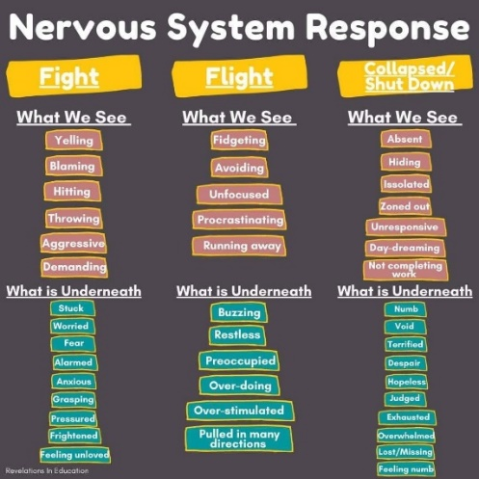

In addition, we very much recommend that you look at the Youngminds website and in particular some of their free online training courses for schools to help support young people with their SEMH needs. Free online training courses (youngminds.org.uk) 

Very best wishes,
Jackie Jones and Anne Constable
Advisory Teachers for Somerset Virtual School and Learning Support Team

